ESG Monthly Draw Report Scheduling Guide

- The report is located at the following location:
  - Click on the Magnifying Glass to open the Report

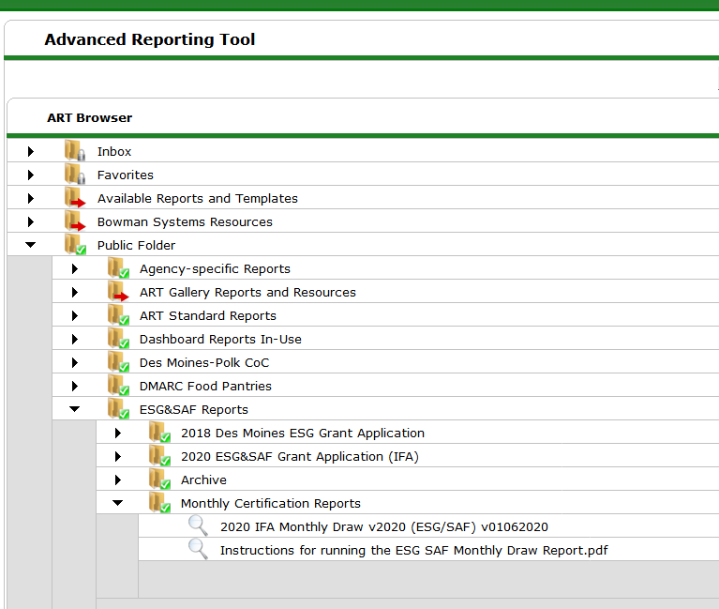

- CLICK “Schedule Report” to open the report scheduling prompt.
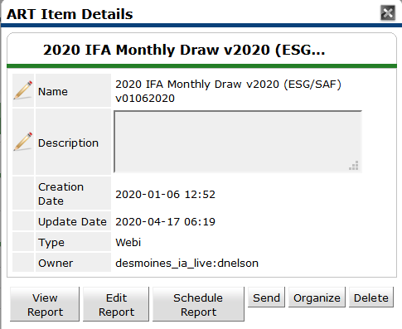

- Select your desired provider project via the “Project(s)” prompt. Skip the EDA Provider prompt and proceed to Report Start Date and Report End Date + 1 Day. Once dates are entered, click Next.

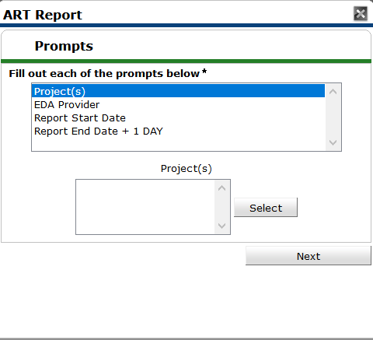
- On the “Schedule Report” screen, the user can rename the report to a custom name. Select one of the “Report Format” options. Formats include PDF and Excel. Next, search for the user’s inbox to whom the report should be send periodically using the “Search” function. Finally, select the interval for the frequency of the report. For monthly reports, schedule the interval to run the report once.

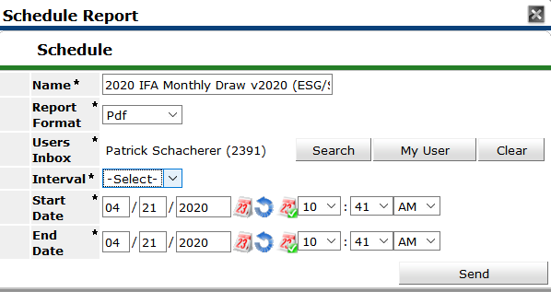

- Once the report has finished running, it will appear in the user’s ART Inbox.

